SMART STITCHES DESIGN DOCUMENT

Detailed description of technical solutions behind the project

Homework Tips Checklist for Parents

# Stake Holder

Project name: Smart Stitches with Love

Branch name: SmartStitchesWithLove

Reviewer: Mr. Hassan Ismail

Assigned Developers : Enas Bitar & Karam Thebian

# Scope Goal

Web Design for a client specialized in handmade knitting , the web design is a simple single page , containing a header , a banner and 4 main sections included in the main page , these sections are the about us , the contact us and the product section titled as Shop.

|  |  |
| --- | --- |
| WHAT SHOULD BE DONE | WHAT SHOULD NOT BE DONE |
| Start with the front-end process of the web page | Changing designs before client approval |
| Get the final feedback of the front-end page |  |
| Then start with the back-end |  |
| End the whole project by connecting the two |  |
| That means ability to edit the products section |  |
| Hosting the project |  |
| Making sure the client is able to use it efficiently |  |

2

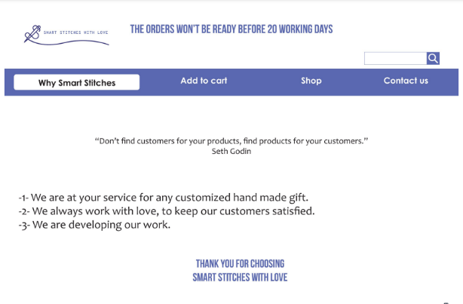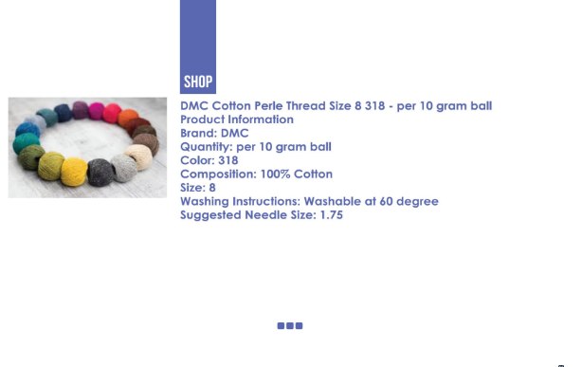

1

4

3



# **Flow Chart dIAGRAM**

**Files to be created**

**Files to be created**

**Components**:

1. Banner : css + tsx
2. Header : css + tsx

**Pages:**

1. Why: css + tsx (text)
2. Shop: css + tsx (scrollable)
3. Contact us: css + tsx (routed text)
4. Footer: css + tsx (text))

**Products**:

* Data coming from data-base

**Operations**

1. Put: Put product
2. Delete: delete product
3. Update: update product
4. Select: select all products

**Where client edits the products**

**Where user views the page**

**Front end**

**Back end**

FOOTER

CONTACT US

SHOP

WHY

LOGO NOTE SEARCH BAR

WHY SHOP CONTACT US

# **Technicalities**

Smart stitches Front-end:

In the src:

* **Folder Assets: including Photos/Logos**

1. Background-images: images of section contact us & footer image
2. Banner-icons: logo and searching icon
3. footer-icons: social media icons

* **Folder *Components*: including:**

1. banner :folder
2. file : Banner.tsx
3. file :Banner.css
4. Header : folder
5. file : Header.tsx
6. file : Header.css

* **Folder *Pages*: including:**

1. WhySmartStitches :folder
2. file : WhySmartStitches.tsx
3. file : WhySmartStitches.css
4. Shop : folder
5. file : Shop.tsx
6. file : Shop.css
7. ContactUs :folder
8. file : ContactUs.tsx
9. file : ContactUs.css

* **Folder *Services*: including:**

1. http-comon.ts
2. productservice.ts

* **Folder *Store*: including:**

1. Actions
2. ProductsAction.ts
3. Reducers
4. Index.ts
5. productsReducers.ts
6. Selectors
7. ProductsSelector.ts
8. Thunk
9. productsThunk
10. Store.ts

Smart stitches Back-end:

* **Folder *repositories*: including:**

1. IProduct-Repository
2. Product-Repository

* **Changes to appsetting.json:**
* **Folder *Data*: including:**

1. ProductsDbContext

* **Folder *Models*: including:** 
  1. Products.cs
* **Folder *InputModels*: including:**

1. CreateProductInputModel.cs
2. UpdateProductInputModel.cs

* **Folder *Dtos*: including:**

1. ProductDto.cs

* **Folder *Controllers*: including:**

1. ProductController.cs

* **Folder *Validators*: including:**

1. CreateProductRequestValidation.cs
2. UpdateProductRequestValidation.cs

* **Initiating the migration folder through terminal**
* **Changes to program.cs:**

**Test cases**

1. Checking whether clients are able to make all edits to the products through login button

**QAs**

Hosting ??

Files to be created (Path): DEF Zone => CreateEditProduct => CreateEditProduct .tsx

Files to be updated (Path): redux store => Reducers => productsReducers.tsx

Methods and logics needed, and why!

Third-party libraries (Plugin) needed, and why! And add description about them in the Readme